MSc
SCSE/MSC/01/09/Submission

NANYANG TECHNOLOGICAL UNIVERSITY
SCHOOL OF COMPUTER SCIENCE & ENGINEERING

MASTER PROGRAMMES BY COURSEWORK & DISSERTATION
SUBMISSION OF DISSERTATION

Notes to Candidate(s):

- Two soft-bound copies of the dissertation must be attached to this form, Section I of which must be completed and signed by the candidate(s). After completing Section I, please hand this form to your supervisor for his attention.
- The supervisor will arrange for the examination of the dissertation with the examiner (assigned by the school) by completing Section II. The supervisor may arrange with the examiner for a demonstration or presentation.
- When the Examiner is satisfied with the quality of the report, he will fill in Section III, else he will return the marked thesis to the Supervisor for amendment.

- The final dissertation, after examination and amendments (if any), must conform to the following format:
  - PDF on international size A4 (210mm x 297mm) paper;
  - Each page must have a left hand margin of 3cm, all other margins are 2cm.;
  - The dissertation must be preceded by the following: title page, declaration (for joint submissions only), abstract, acknowledgments, table of contents and summary, all of which must be bound with the dissertation;
  - The title and author’s name must be given in block letters on the cover of the dissertation;
  - Pages must be numbered in one continuous sequence in Arabic numerals. Where a dissertation consists of more than one volume, one numbering sequence must be used.

__________________________________________________________________________________________________

Section I: To be Completed by Candidate

Degree Registered for | : | MSc (Embedded System)
Title of Dissertation | : | A STUDY ON PERFORMANCE HURDLES FOR HETEROGENEOUS 3D-MPSoCs
I/We submit 2 soft-bond copies of my/our dissertation in partial fulfillment of the above degree for examination. I/We have read and understood the Notes to Candidate(s) above.

 | Name of Candidate  & Matric No. | Registration No. | Signature | Date  (dd/mm/yy)
1. | Dang Hoang Tung  G1601337K |  | 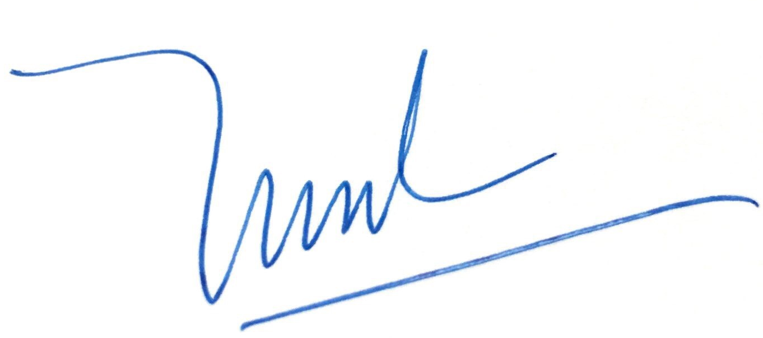 | 20/07/2018

Section II: To be Completed by Supervisor(s)

- The candidate(s) named on Page 1 has completed the writing up of his dissertation to my satisfaction. In my opinion the dissertation is ready for examination.

- Remarks (attach separate sheet if necessary):

Ready for review

Name of Supervisor(s) : __Arvind Easwaran_ Signature & Date : _20/7/18_ 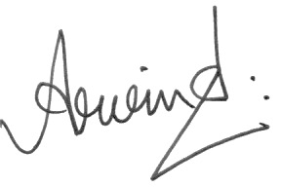

Section III: To be Completed by Examiner(s)

- The candidate(s) named on Page 1 has/have* completed his/her dissertation to my satisfaction for the MSc.

- Remarks (attach separate sheet if necessary):

Name of Examiner(s) : _____________________________________ Signature & Date : ___________________

Section IV: To be Completed by Assistant-Chair-Computer Science & Engineering (Graduate Studies)

PASS / RE-SUBMIT*.
Comments (if any).

_________________________________________ _______________
Signature Date

*Delete accordingly

